Nathan Villicaña-Shaw

November 27, 2015

**Wave Cave Proposal: *Cathode Ray Tubes***

Four CRT TV’s are set up in a semicircle each on its own small table. In front of each TV is a video synthesizer with its circuitry exposed. The TV’s and the synths are all connected in one large feedback loop with each synth reacting to electric field emanating from the TV it is placed in front of. Gallery goers are invited into the space to discover that their bodies natural electrical properties are all they need to begin seizing control over the installations a/v feedback loop.

**Project Description**

*Cathode Ray Tubes* is an immersive, interactive, audio-visual installation that focuses on sonifying and visualizing electronic circuits while exploring the human body as an electronic component. *Cathode Ray Tubes* creates a video feedback loop out of four CRT TV’s and four NES knock-off consoles (Retrons). The Retrons are literally turned inside out (the circuit boards are exposed while the buttons, controller jacks and cartridge ports are removed) and repackaged in custom enclosures.

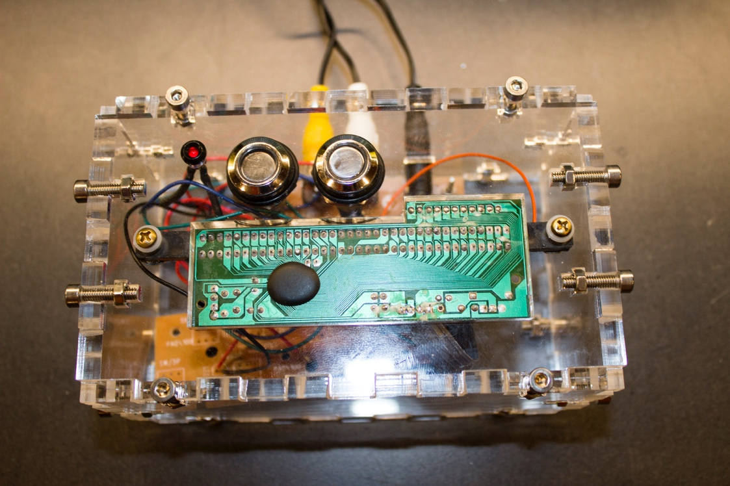

**Image 1:** Retron prototype – installation version will not have buttons and the LED will be moved inside the enclosure, leaving only the circuit board.

With their circuitry unveiled, and with no software to guide their computational logic, the Retrons becomes very susceptible to electro-magnetic interference. The Retrons are effectively transformed into 8-bit a/v synthesizers that generate their output based on the electrical noise present in the circuit.



**Image 2:** Typical output from a Retron a/v synthesizer

Four modified Retrons are placed in close proximity to CRT TV’s within the installation space. This allows the static electricity produced by the TV’s to interact with the Retrons circuitry, modulating their audio and video outputs. The Retrons are connected in such a way that the video output of each Retron reverberates through all other units in one large feedback loop. Audio is generated for the space by the Retrons in the same manner as the video. This combined configuration creates a resting state for the installation that is in constant flux as all the Retrons and TV’s are feeding off of each others electrical fields.

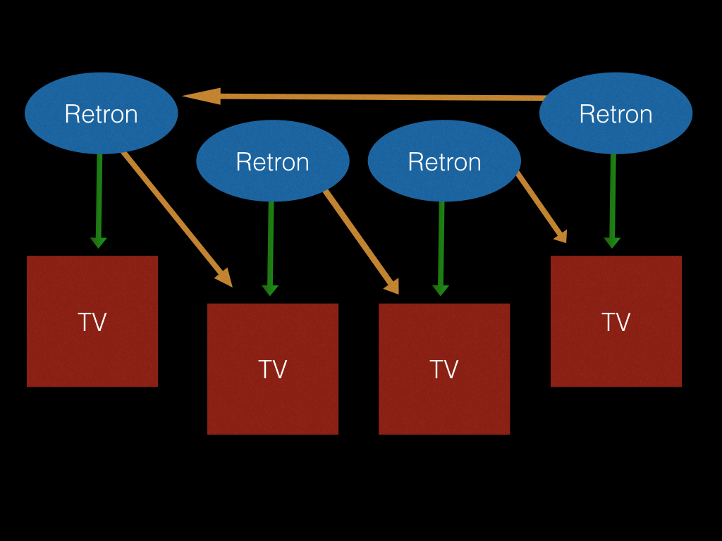

**Image 3:** Electronics Diagram:yellow arrows show video flow while green arrows show audio routing.

As the entire system has been designed emphasizing instability and assailability, the human body becomes an effective controller (due to its inherent electrical properties). Acts such as waving a hand in front of a TV, waving a hand above a Retron, touching a TV, touching a Retron, moving a Retron’s angle or distance from a TV and combinations of the above (touching a Retron and placing your hand a few inches away from a TV) will produce different effects that resonate throughout the feedback loop. If multiple people are in the gallery space, the installation scales nicely as the number and complexity of the effects produce even more drastic results in the Retron feedback loop.

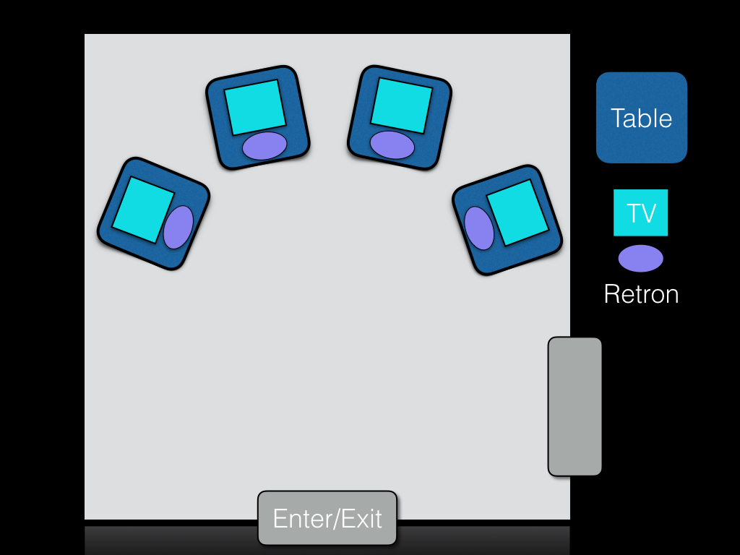

**Image 4:** Galley Layout for the WaveCave Galley Space

*Cathode Ray Tubes* is designed to create a space of discovery that invites viewers to forge their own personal experience with the environment and its circuitry, and the goal of the installation is not that each gallery goer manipulates the feedback loop in every possible way, but rather that most gallery participants explore a relationship with the circuitry that feels unique to them.

*Cathode Ray Tubes* explores unconventional approaches for human-circuit interaction by eliminating all sensors, buttons, knobs and all other “middle-men” between the circuit and the user. It empowers us to utilize the natural electrical properties of our bodies to directly control the normally hidden circuitry that we are surrounded by but removed from in our daily lives.

**Links:**

**Cathode Ray Tubes** – POF Videos -

Typical Retron video output

<https://vimeo.com/143563194>

Proof of concept for the feedback loop using two TV’s and two Retrons.

<https://www.youtube.com/watch?v=3WovzVABXLc>

**Digital Rain**: Grid of 196 relay switches that sonified weather reports from around the country in real time.

<https://youtu.be/x87EnplNm88?t=1m15s>

**Toys:** Controlling circuit bent children’s toys with a custom interface.

<https://www.youtube.com/watch?v=Lxgry-iFIAs>

<https://www.youtube.com/watch?v=jlbxIBrCLqA>

**1990**: Interactive Circuit bent SNES’s:

<https://youtu.be/C2SuXUqXMpE?t=23s>

<https://youtu.be/__MrRWzerhc>

**Website:**

<http://bitdeph.com/>

**Bio:**

Nathan Villicaña-Shaw creates installations that explore and question our ever changing relationship with technology. Interested in defining new boundaries for human-circuit interaction, Nathans previous installations have featured armies of circuit bent toys, circuit bent Super Nintendo’s as well as relay grids that sonify global weather data. Nathan spends most of his time creating interactive installation art, composing, hacking and working as a Python developer and creative technologist. Nathan is a MFA candidate and BFA alum from the MTIID department at CalArts where his research focuses on developing and working under the philosophy of OpenHacking; a discoverist framework for art creation via the exposure of electronic systems for subversive injection. Before studying at CalArts Nathan played Bass in various punk and surf bands from the SF East Bay such as The Molestations and The Machetes.